**Critical Thinking Assignment Module Three Assignment**

**Integer Pointers Program**

Victor Enogwe

Computer Science, Colorado State University - Global Campus

CSC450-1: Programming III

Reginald Haseltine

May 5, 2024

In this module, we’ve looked at working with exceptions and functions and studied pointers and arrays.

I created a program that asks the user to enter three integer values as input. Stores the values into three different variables. For each variable, it creates an integer pointer to dynamic memory and displays the contents of the variables and pointers. The new operator and delete operators are used to manage memory.

**Program Pseudocode**:

PROGRAM: Integer Pointers  
- This program collects three integer values as input. Stores the values into three different variables.  
 For each variable, it creates an integer pointer to dynamic memory and displays the contents of the variables and pointers.  
 The new operator and delete operators are used to manage memory.  
  
BEGIN  
 BEGIN  
 create a main.cpp file.  
  
 declare a "str_trim" function that takes a string and returns the string with white space removed from both ends. Make sure the initial string is not mutated.  
 declare a "get_input" function that prompts a user to enter an integer string and returns a value of the type int.  
 The function takes one argument: a string "instruction" to tell the user what to enter.  
 Use the "str_trim" function to trim the string and the "int" function to convert it to an integer before returning it.  
 Save the final value in a pointer and return it.  
 END  
  
 declare a main function to run the program.  
 inside the main function:  
 - using the "get_input" function collect the user input thrice and save them in different variables.  
 - store the value of the pointer variables created above in separate variables.  
 - Print out each of the variables above, the value and its pointer.  
 - deallocate the pointer variables created using the "delete" keyword.  
END

**Main.cpp:**

/*  
 * Program: Integer Pointers Program  
 * a program that will take three integer inputs from a user using an instantiated pointer.  
 * The program prints the values of the pointers and their reference.  
 * The program deallocates the pointer memories initialised using the "new" keyword.  
 */  
  
#include <iostream>  
#include <string>  
#include <regex>  
  
using namespace std::regex_constants;  
  
using std::cout;  
using std::cin;  
using std::getline;  
using std::string;  
using std::regex;  
using std::regex_replace;  
using std::regex_match;  
using std::runtime_error;  
using std::stoi;  
/*  
 * str_trim  
 * trims the leading and trailing whitespaces in a string  
 * avoids mutating original string  
 * returns the trimmed string  
 */  
string str_trim(const string& value) {  
 string s;  
  
 s.assign(value);  
  
 return regex_replace(  
 regex_replace(s, regex( "^\\s+$" ), ""),  
 regex( "\\s+$" ),  
 ""  
 );  
}  
  
/*  
 * get_input  
 * asks a user to enter an integer  
 * recursive  
 *  
 * returns the input integer pointer  
 */  
int* get_input(const string& instruction) {  
 try {  
 cout << instruction;  
  
 string input;  
  
 getline(cin, input);  
  
 string trimmed_input = str_trim(input);  
  
 int *pointer = new int;  
 *pointer = stoi(trimmed_input);  
  
 return pointer;  
 } catch (const runtime_error& error) {  
 cout << error.what();  
  
 return get_input(instruction);  
 }  
}  
  
int main() {  
 cout << "Collecting Three Integer Inputs.\n";  
  
 int* first_input_pointer(get_input("Enter the first integer: "));  
 int* second_input_pointer(get_input("Enter the second integer: "));  
 int* third_input_pointer(get_input("Enter the third integer: "));  
  
 int first_input = *first_input_pointer;  
 int second_input = *second_input_pointer;  
 int third_input = *third_input_pointer;  
  
 cout << "First Input Pointer: " << first_input_pointer << "\n";  
 cout << "First Input Value: " << first_input << "\n";  
 cout << "Second Input Pointer: " << second_input_pointer << "\n";  
 cout << "Second Input Value: " << second_input << "\n";  
 cout << "Third Input Pointer: " << third_input_pointer << "\n";  
 cout << "Third Input Value: " << third_input << "\n";  
  
 delete first_input_pointer;  
 delete second_input_pointer;  
 delete third_input_pointer;  
  
 return 0;  
}

**Git Repository Image: Git Branch = Main** **- https://github.com/victor-csu/****CSC450-Module-Three-Critical-Thinking/tree/main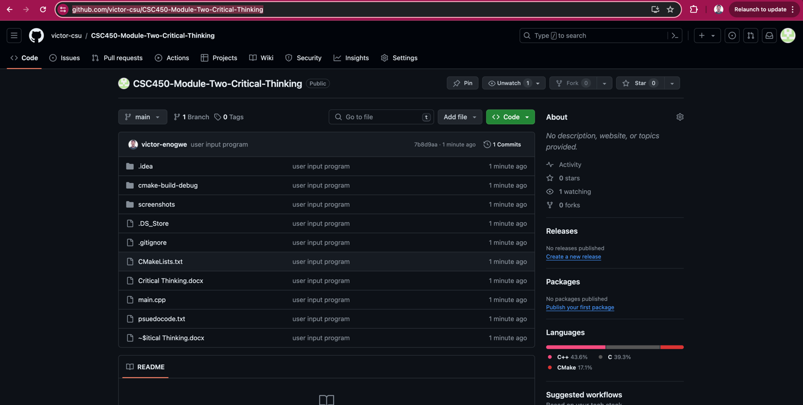****Happy Path Execution Screenshot – Fictional Person - CSC450_CT3_mod3-0-execution-output:**

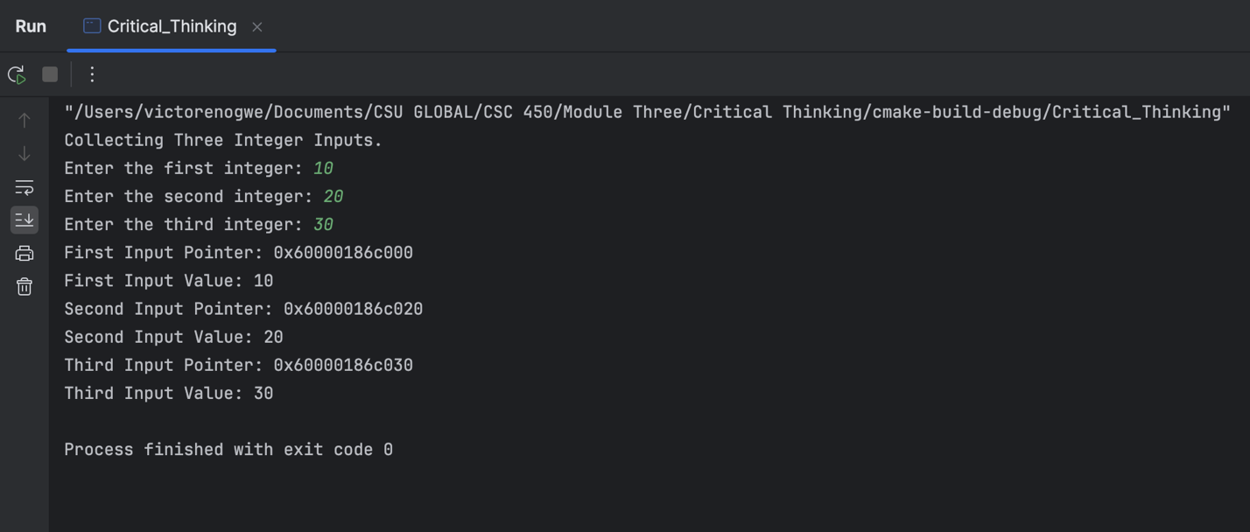

References